INFO 6205

Program Structure and Algorithms

Spring 2021

Covid-19 Simulation Report

**Project team members:**

**Divya Kulkarni (001543678)**

**Jaeline Granda (ID)**

**Varad Ratnakar Desai (001465732)**

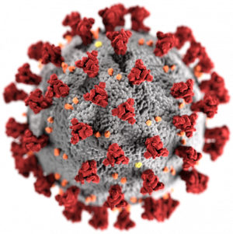

**Introduction:**

Coronavirus disease 2019 is a contagious disease caused by severe acute respiratory syndrome coronavirus 2 (SARS-CoV-2). The virus spreads primarily through droplets of saliva or discharge from the nose when an infected person coughs or sneezes. The first known case was identified in Wuhan, China, in December 2019. The disease has since spread worldwide, leading to an ongoing pandemic. Over 137 million people have been infected with the virus while 2.95 million people have died. The United States makes up over 20% of those cases.

Most people infected with the COVID-19 virus will experience mild to moderate respiratory illness and recover without requiring special treatment. Older people, and those with underlying medical conditions like cardiovascular disease, diabetes, chronic respiratory disease, and cancer are more likely to develop serious illness.

**Aim of the Project:**

Our objective is to simulate the virus transmission of SARS-CoV-2, the pathogen behind COVID-19. The simulations take into account different measures taken throughout the pandemic including no restrictions, lockdown, quarantine, social distancing, mask wearing, testing, and vaccinations.

**Complete Project Details**

* R factor: We have measured the R factor to explain disease transmissibility, which indicates how many non-infected people were infected by the total number of infected people.
* Lockdown: To calculate the absolute effect of a lockdown, we have conducted a study without the impact of other control measures such as social distancing and mask wearing. The full lockdown results in the reduction of R number are shown on the graph.
* Usage and effectiveness of masks: We have demonstrated that community mask wearing will help stop the spread of this infection, both as a source control measure to keep infected people from spreading it and as a protective measure to keep wearers from being infected.
* Prevalence of testing and contact tracing: Covid testing and contact tracing are methods for identifying people infected with the virus so that steps can be taken to delay and avoid its spread. We are analyzing this by calculating the number of people that have been tested and recommending a strategy to keep them isolated in order to slow the spread.
* Availability and efficacy of the vaccine: We are simulating the effectiveness of vaccines to demonstrate the overall reduction in the disease curve.
* Quarantine: Demonstrating and showcasing how quickly the infection surges without any measures but as soon as we start showing quarantine measures to contain the spread, the infection curve starts dropping.
* Social Distancing: We're using Social Distancing as a preventative measure to keep people at a healthy distance from each other. This is shown by people moving more slowly in public spaces.

**Implementation (Charts/Algorithm):**

COVID-19 virus poses a serious threat for human health, social life and development, production and international relations. In this regard, forecasting is critical for preventing the spread of the disease and implementing preventive measures based on COVID-19's epidemiological characteristics.

We have studied the modeling of COVID-19 epidemic and the implementation of steps to combat the virus at the scale of the population. Our model consists of we have considered the following stages:

* Disease Spread with no Measures
* Covid Testing
* Mask Usage
* Lockdown and Quarantine
* Infection Control with Vaccination
* Social Distancing Effects

**1. Disease Spread with No Measures**

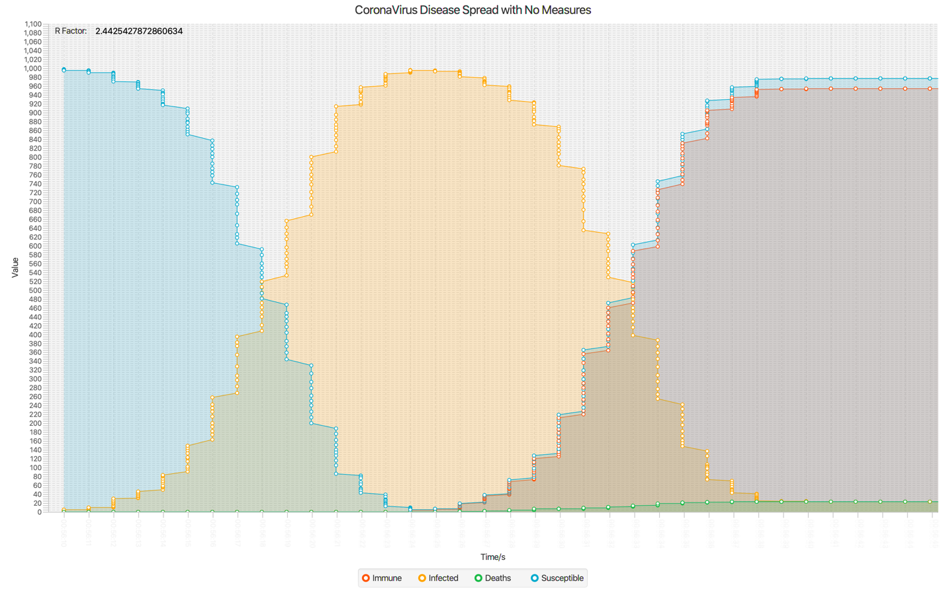

**Assumptions:**

We start with one person as infected at first. Assume a minimum proximity distance of 10 units between two people to become infected. There is a high risk of disease transmission when an infected individual comes into contact with another within this radius, as seen in the graph. People who aren't considered super-spreaders now might become super-spreaders in the future.

**Output:**

The infection grew at a faster rate without any measures as shown by the curve (shown in orange). Infection reached its peak within a very short duration of time. This has also been supported by a sharp decline in susceptible curve (in blue). After staying infected for assumed 140 units, we see people become resistant/gain some immunity (in red) or they may die. Death is a possibility in 20% of cases.

**2. Covid Testing**

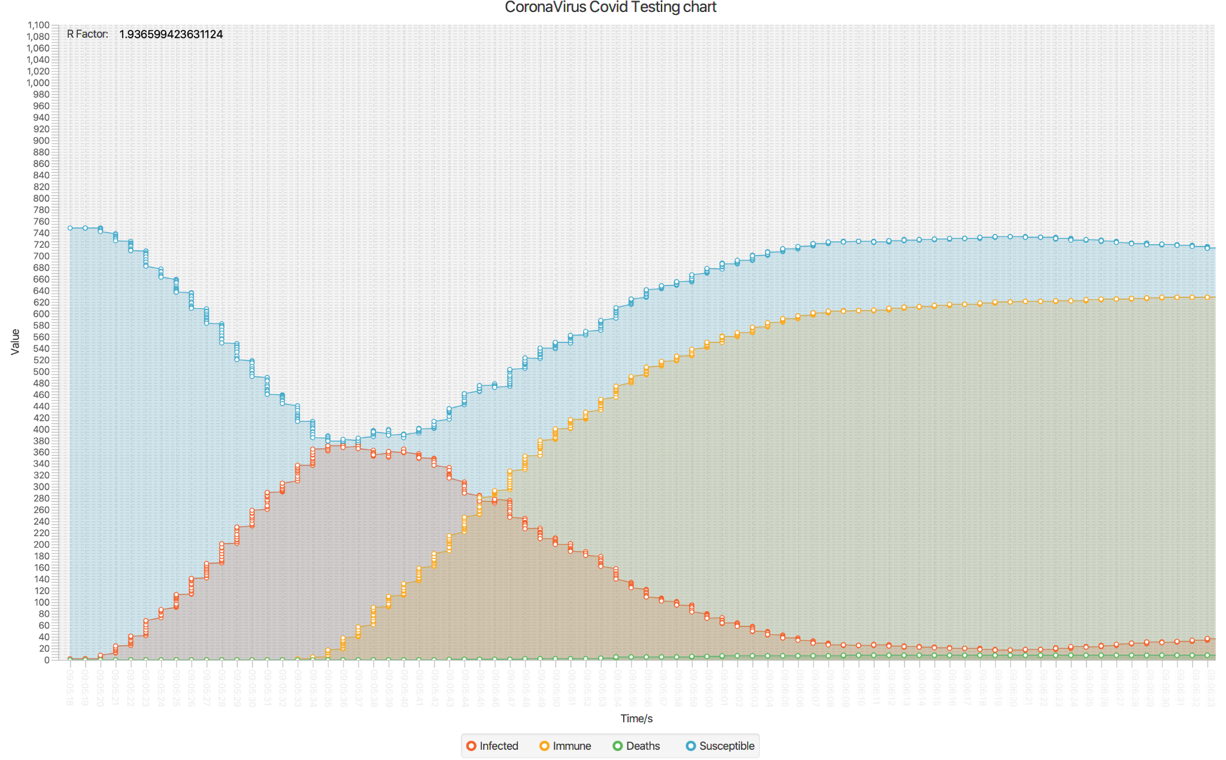

**Assumptions:**

We assume that 40% of the population would be randomly sampled in order to better track and manage the spread. People who test positive are likely to be quarantined for two weeks in order to slow the spread of the disease.

**Output:**

It allows for the isolation of infected people as well as the tracking and quarantining of their contacts. Infection curve (in red) started reducing and hence improving the immunity curve (in orange). 20% of death cases are shown by the Death curve (in green).

**3. Mask Usage**

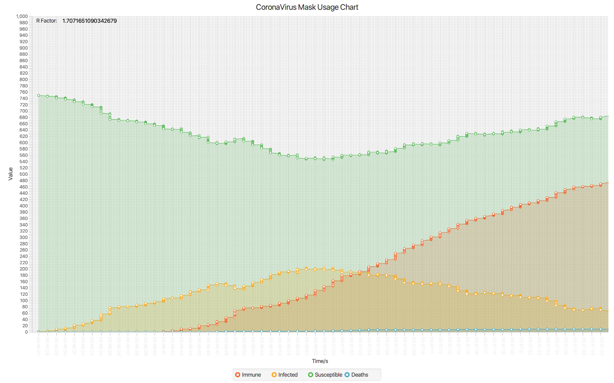

**Assumptions:**

Once an individual infected with the corona virus is added to the population, we need the population to wear masks after 10% of the population has been contaminated.

**Output:**

Peak of the infected curve (in orange) is smaller in height as compared to the disease spread with no measure curve shown in ‘*Disease Spread with No Measures*’. More and more people will get immune over the period of time (in red) as the infection curve is curbed due to the mask usage. Implementing the mask wearing does in fact reduce infection curve.

**4. Lockdown**

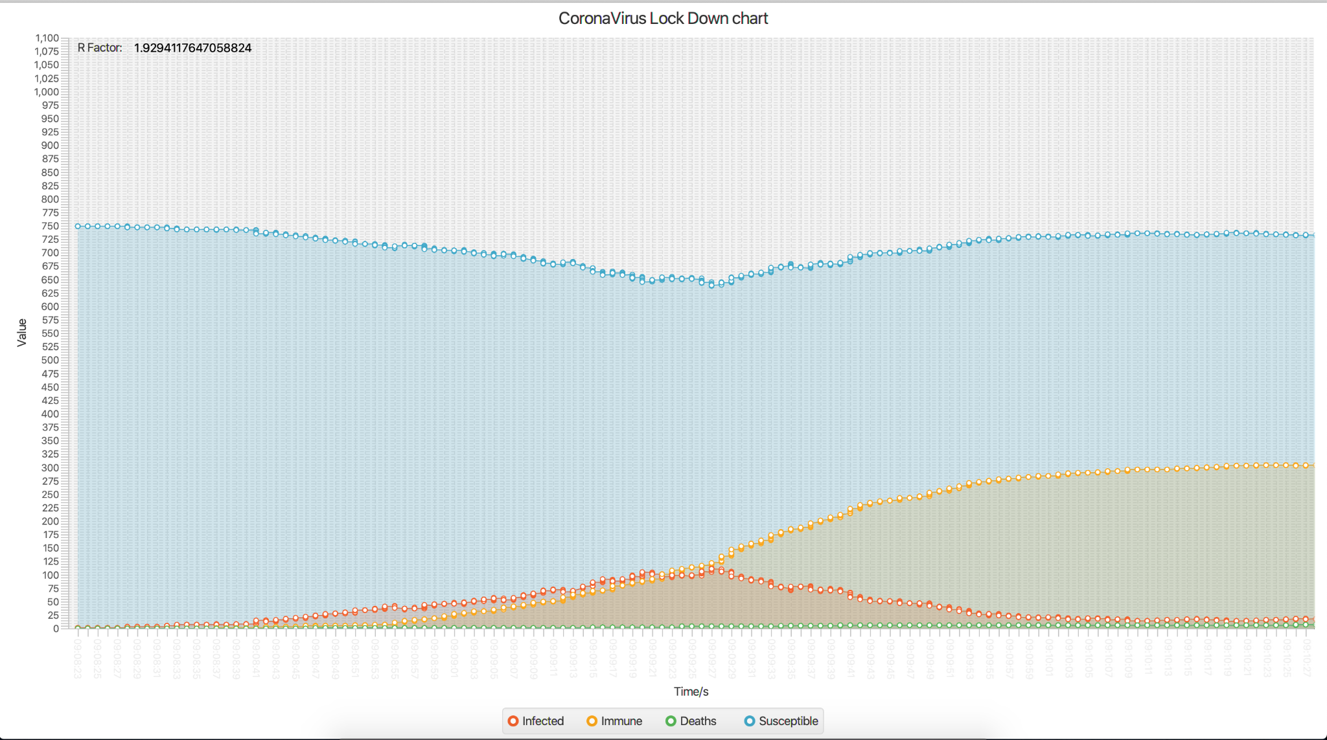

**Assumptions:**

Lockdown is in place, that puts restriction on the movements. We have accommodated this condition by allowing only 30% of population to move and the other 70% will be population who are restricted to any movement. Also the moving population will be in movement only for 30% of the time.

**Output:**

So, the infection curve has a long tail before reaching its peak which shows the effect of a good measure to subside the spread of disease. Also, it can be noted from the graph, the peak of the infected line is smaller than the ‘*Disease Spread with No Measures’* indicating comparatively lesser people getting infected. People will get immune after completing the assumed infected period of 140 units.

**5. Quarantine**

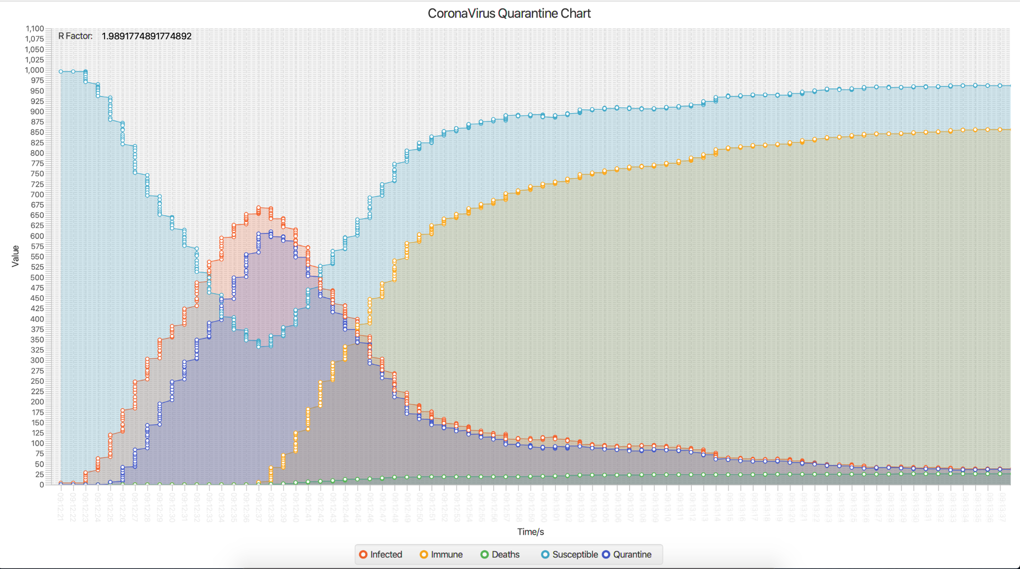

**Assumptions:**

The graph may appear to show a large increase in COVID-19 cases, but this accurately represents how the virus is affecting people. Quarantine, an another form of distancing is modeled by initially setting only one infected person assuming a very small number of social contacts for each quarantined node.

**Output:**

The aim was to make the infection curve (in red) flatten, suggesting the need for strict quarantine measures to prevent the spread of the disease. We can see that the disease spread has been regulated and immunity has increased as a result of isolating infected people as soon as the infection rises. Quarantine curve moves along with the infection curve indicating more number of people are put into the quarantine zone as they get infected. The curve decreases as infection subsides.

**5. Infection Control with Vaccination and Mask**

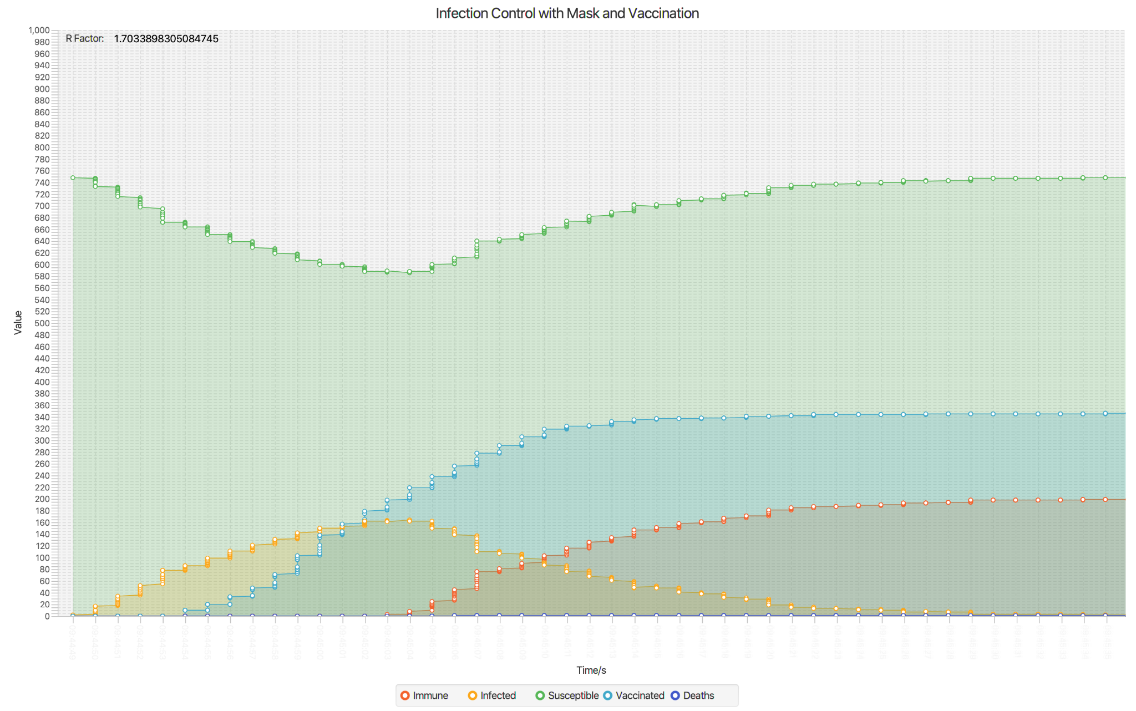

**Assumptions:**

Population will be using masks as a preventive measure and random 10 % will get vaccinated per unit time as we progress.

**Output:**

Infection rates (in orange) due to COVID-19 have fallen dramatically in the vaccinated population, indicating a significant increase in immunity (in red). The more people are vaccinated, the better will be the immunity and lesser will be the infection rate. As more people start getting vaccinated, we observe a sharp decline in the infected people as less and less new people get contracted. Initially we see drop in susceptible people as they’re counted in infected group, but the curve rises as infection is slowing down. This shows the high probability of an individual to still get contracted after getting a vaccine or using masks.

**6. Social Distancing Effects**

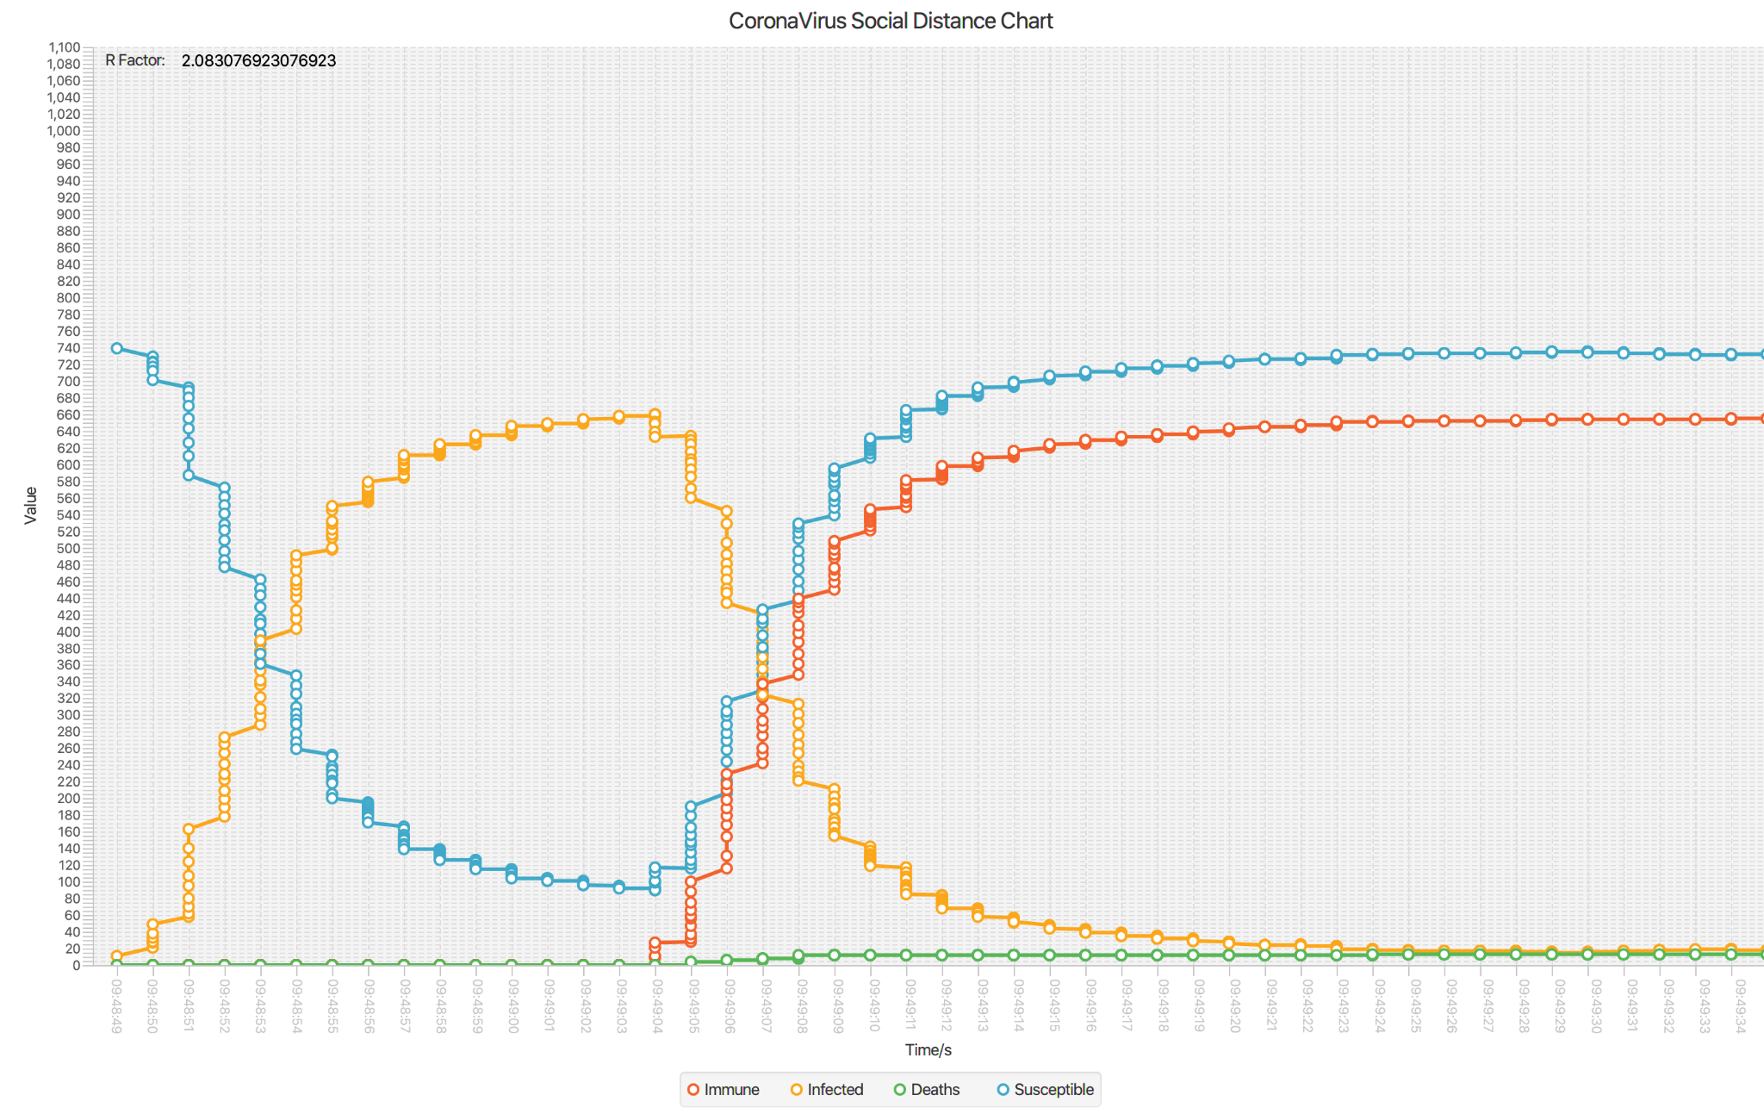

**Assumptions:**

Population is following social distancing guidelines, if two people come inside the assumed social distancing radius of 60 units then they will try to move farther away. If people come closer than the assumed infected radius of 10 units, they may spread the infection to others.

**Output:**

Line graph of infected people grows at a very higher rate initially before enforcing the social distancing. Once social distancing is in place, we can see decline in new cases of people getting infected. The curve remains very low for the infected category over the period of time as social distancing is still in place. Death and immunity also play a role after a person's infected duration has completed.

**7. Social Distancing and Quarantine Effects**

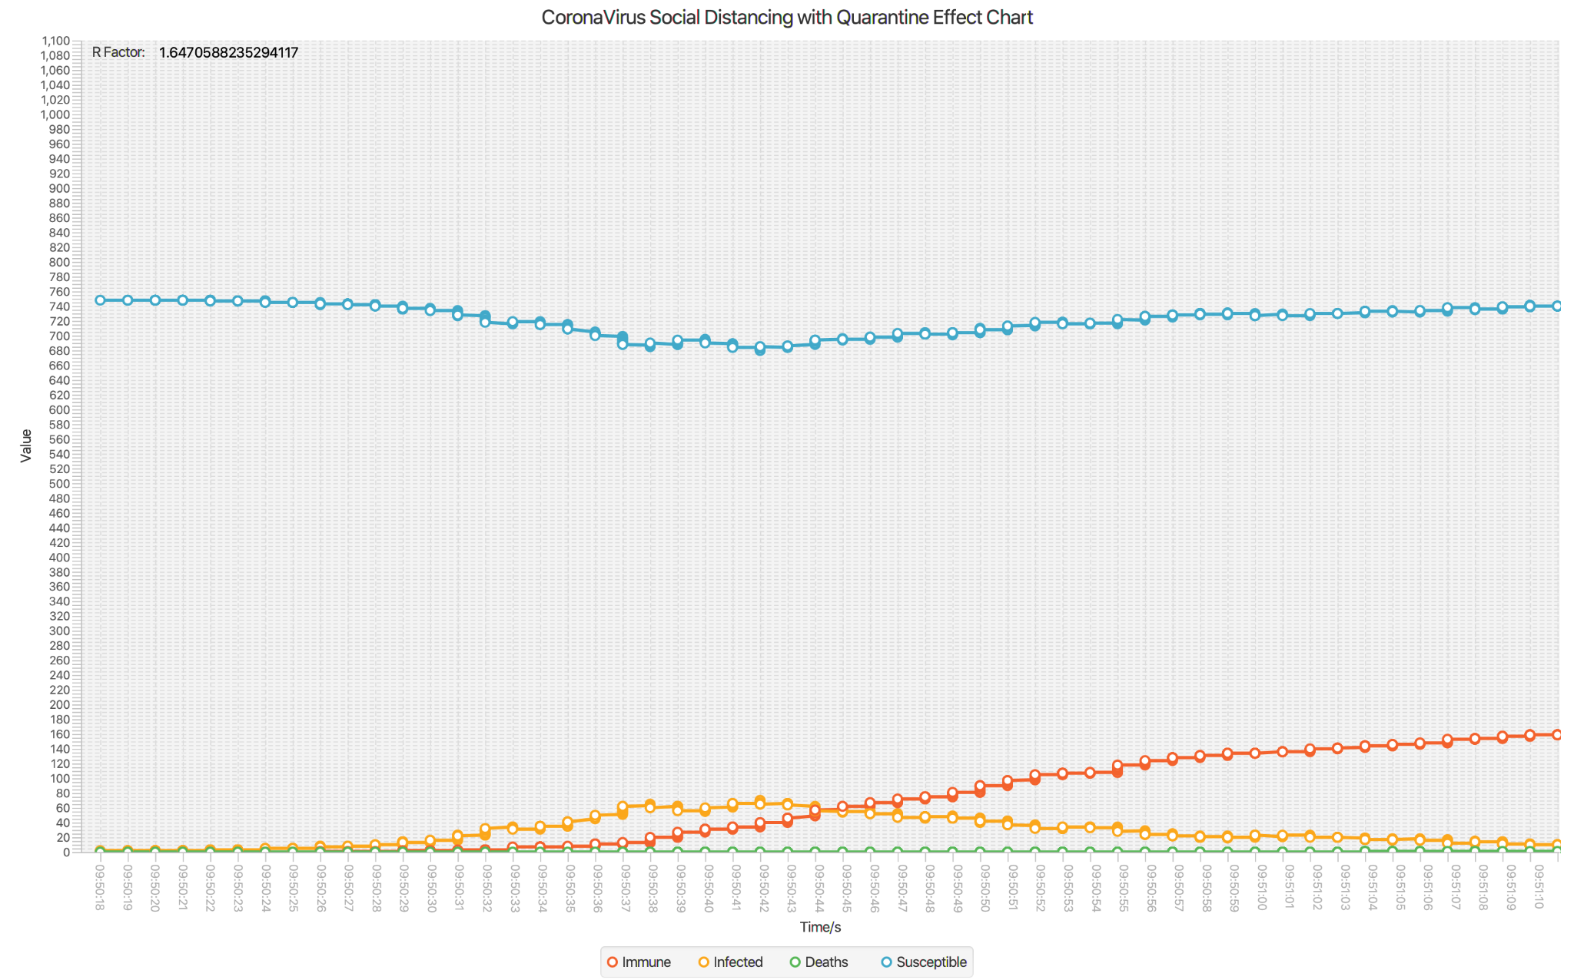

**Assumptions:**

When a person is quarantining then moves only for 10% of the time. Rest of the population will remain healthy and do not intersect with this population while following the social distancing protocol to move only 50% of the time to reduce the spread.

**Output:**

Infected curve is seen to be growing at a very slower pace and has the lowest peak among all the other cases. Due to the restrictions in place, the infected curve started to grow much after the first case was found. Death curve is almost flattened and shows negligible growth. These graphs show the best measures to be taken for Covid.

**Conclusion:**

* Best case:
  + When combined all of the social distancing with quarantine, lockdown, mask usage and vaccination will prove to be most effective. Infection curve will be starting at a later stage and will grow at a much lower pace comparatively to all other cases. All these measures prove helpful in controlling the disease spread. Individually each of the measures have shown to control the disease spread. Combined measures will have greater impact.
* Worst case:
  + When there are no measures in place such as ‘*Disease Spread with No Measures*’ infections have grown at a very fast pace. Infected curve attains its peak in a short duration of time and has a large number of infected people.
* Invariant:
  + At every iteration, number of susceptible + number of infected people + number of died = total population. This equation remains constant before and after each ‘actionPerformed’ is called which manipulates the number of infected and susceptible. During the execution of the method loop invariant is not maintained.

**Unit Tests cases:**



